A Deep Learning Architecture for Cryptocurrency Price Forecasting utilizing Business Intelligence

1st Asep Surahman Sulaeman
Master of Informatics, Faculty of Engineering, Computer, and Design
Nusa Putra University
Sukabumi, Indonesia
asep.surahman@nusaputra.ac.id
2nd Deden Witarsyah
Master of Informatics, Faculty of Engineering, Computer, and Design
Nusa Putra University
Sukabumi, Indonesia
deden.witarsyah@nusaputra.ac.id
3rd Aswan Supriyadi Sunge
Department of Informatics Engineering, Faculty of Engineering,
Pelita Bangsa University
Bekasi, Indonesia
aswan.supriyadi@pelitabangsa.ac.id

Abstract — Forecasting Bitcoin prices in practice remains considerably more difficult than much of the published literature suggests. This paper presents a four-layer automated Business Intelligence pipeline that injects forecasting outputs directly into an enterprise decision-support system and computes the Sharpe Ratio and Value-at-Risk in near real-time. Four models XGBoost, LSTM, GRU, and the Informer Transformer were evaluated under a Walk-Forward Validation scheme using 43,786 hourly candlestick observations of BTC/USDT from 2021 to 2026. In the raw predictions, the GRU achieved the lowest error (RMSE = 0.1058, p < 0.001). However, when these same outputs were passed through the BI layer, the ranking was reversed: the LSTM achieved the highest directional accuracy (72.3%) and the highest Sharpe Ratio (1.45) despite a higher RMSE. The key finding of this paper is that there is a mismatch between the model that performs best on conventional error metrics and the model that generates the most favorable risk-adjusted trading outcomes; RMSE and similar loss metrics do not indicate whether a forecast is useful for trading. Usability results were similarly favorable: the pipeline-based Power BI prototype received a score of 86.4 on the System Usability Scale, within the "Excellent" range, indicating that institutional users could operate the system independently rather than only in a controlled research setting.
Keywords Financial Informatics, Business Intelligence, Deep Learning, XGBoost, LSTM, GRU, Informer Transformer

Introduction
Bitcoin is notoriously hard to predict. Prices change regimes without warning, crash or spike around macro-economic shocks and break the assumptions on which conventional economic models are based [1],[2]. Consider ARIMA, the default for decades in textbooks: it assumes covariance stationarity, and hourly cryptocurrency data repeatedly violates this assumption [3], [4]. Neural network approaches have therefore been proposed as a remedy, since they are agnostic to stationarity and learn nonlinear temporal patterns directly from raw data [5], [6].
However, a common shortcoming in much of this literature remains largely unaddressed: studies typically report only RMSE or MAE, as though a lower value alone were sufficient evidence of a good model. What matters more to a portfolio manager is whether the model correctly predicted price direction and whether acting on that prediction would have generated a risk-adjusted return; RMSE cannot answer either of these questions [7], [8]. This constitutes a gap between laboratory-measured forecasting accuracy on one side and what enterprise Business Intelligence (BI) platforms actually require on the other [9]. Closing this gap requires translating raw model outputs into risk indicators and KPIs that comply with institutional risk-governance standards [10].
This paper aims to address this gap. We construct what we term an "End-to-End BI-ML Framework" that extends beyond model training to include automated Walk-Forward Validation, structured Data Mart storage, and a live Power BI dashboard displaying enterprise-level risk metrics in real time. Four model families are tested within this framework: XGBoost (tree-ensemble), LSTM and GRU (recurrent), and the Informer Transformer (attention-based), all trained and tested on the same five years of hourly Bitcoin data under identical conditions. This field has evolved rapidly: a decade ago, cryptocurrency prediction relied mostly on linear regression or ARIMA, whereas recurrent, convolutional, and attention-based deep learning architectures now dominate, each new architecture claiming superiority over the last.

Baselines and Deep Sequences (RNNs)
Tree-based ensemble methods have become the standard in financial modelling. Extreme Gradient Boosting (XGBoost) is particularly effective on tabular financial features, as the combination of many diverse trees controls the variance [11], [12]. However, decision tree models do not explicitly encode information about what occurred at time t-1. Zheng et al. [13] explicitly highlight this limitation, noting that financial markets retain memory of past states.
Consequently, researchers turned to recurrent architectures instead. Long Short-Term Memory (LSTM) is the neural network architecture developed by Hochreiter and Schmidhuber [14], based on forget, input, and output gates that allow the network to learn what to remember and what to forget. Cho et al. [15] later designed the GRU to perform a similar task with fewer parameters. Both remain mainstays of current cryptocurrency-forecasting research [16]–[18].

Transformers in Time Series
Transformer architectures subsequently emerged as an alternative. Self-attention [19], originally proposed for language tasks, achieved notable success in time-series problems as well [20]. The Informer [21] goes one step further by replacing full quadratic attention with a probabilistic sparse variant that runs in O(L log L) time, making it computationally feasible for long-horizon forecasting in deployment settings. Since then, models such as PatchTST [22] and TimesNet [23] have achieved considerable further advances. However, for this research, the Informer was selected as the representative Transformer architecture owing to its longer validation history, particularly in hourly cryptocurrency settings, making it a more stable benchmark against which to test the BI integration. Zerveas et al. [24] found that, in practice, Transformers tend to overfit or become computationally prohibitive to train on short, volatile horizons such as one-hour crypto intervals [25], [26] a consideration that is directly relevant to the results reported later in this paper.

The Need for BI Integration and Scope Justification
The literature contains numerous model comparisons [27], [28], yet these rarely extend to actual deployment within an enterprise Decision Support System, where the default yardstick remains RMSE. This raises an important question: does a more accurate forecast actually lead to profitable, operationally useful decisions? The aim of this work is to address this gap by linking deep learning results to a BI layer that delivers usable Sharpe Ratio and Value-at-Risk (VaR) figures for institutional risk governance [29].
Bitcoin was selected as the reference asset for three reasons. First, it is the most liquid, most traded, and most studied cryptocurrency available, making it the obvious reference asset [1], [30]. Second, it trades continuously, 24 hours a day, seven days a week, and exhibits the densest sequential signal among crypto markets. Third, restricting the analysis to a single Binance spot trading pair serves as an experimental control, preventing the liquidity shocks to which smaller altcoins are prone from affecting the results. Extending the framework to multi-asset portfolios is a logical next step, but only after the pipeline has first been validated on BTC.

METHOD
The proposed framework consists of four sequential layers, each feeding its output into the next. Layer 1 ingests raw market data. Layer 2 cleans and reorganizes this data into the feature-rich sequences required by the forecasting models. Layer 3 runs multiple inference models in parallel on the same input data. Layer 4 then takes the output of this model comparison and feeds it into a live BI dashboard, transforming raw input into information that a decision maker can act upon. Each layer is detailed in the following subsections.

High-Frequency Data Extraction
This subsection details the data-ingestion and feature-validation procedures underlying Layer 1 of the framework described above.
All 15 derived technical indicators were first tested with Augmented Dickey-Fuller (ADF) test before feeding to the models. The null hypothesis of the unit root was rejected at 5% level (p < 0.05) for all series, confirming the property of stationarity needed for the proper functioning of sequential deep learning models.

Walk-Forward Validation Protocol
The primary data source used for all experiments in this paper, the Binance hourly OHLCV API, delivered a complete, gap-free candlestick series (see Section II.C for the imputation and leakage clarification requested by reviewers) [31].
More importantly, all model evaluation in this study was performed based on strictly chronological Walk-Forward Validation. It is not a matter of choice when dealing with financial time series: any leakage of future information in training would make the whole set of results meaningless [32].
To address the reviewer’s concern about potential temporal leakage from the imputation step (Algorithm 1, Step 2): the Binance API (BTCUSDT, 1-hour interval) supplied complete, gap-free records, so no interpolation was applied prior to the Walk-Forward split. A secondary fallback path using Yahoo Finance daily data invoked only if Binance is unavailable applies linear interpolation (resample(‘1h’).interpolate(method=‘time’)) using only the two adjacent daily anchor points per gap, which cannot propagate information beyond a 24-hour window and therefore introduces no look-ahead contamination. We also correct an editorial error in the original manuscript: the method used is linear, not polynomial, interpolation. All results reported here use the Binance path exclusively, with the chronological 80/20 split (split = int(0.8 × N)) enforced after feature engineering.
Algorithm 1 4-Layer BI-ML Implementation Pipeline
Input: High-frequency Cryptocurrency OHLCV Spot Data
Output: Risk-adjusted Dashboard Matrix (Sharpe Ratio, VaR)
// Layer 1: Data Ingestion
1: raw_data ← BinanceAPI(symbol=“BTCUSDT”, interval=“1h”)
// Layer 2: ETL Transformation & Feature Engineering
2: clean_data ← LinearTemporalInterpolate(raw_data)
3: Extracted_Features ← GenerateIndicators(clean_data) // MACD, σ_t
4: Folds ← WalkForwardSplit(Extracted_Features, train=720, test=168)
// Layer 3: ML Inference Regimes
5: for each validation_fold ∈ Folds do
6: scale_params ← MinMaxFit(validation_fold.train)
7: weights ← TrainNetwork(validation_fold.train, scale_params)
8: predict_tensor ← weights.predict(validation_fold.test)
9: end for
// Layer 4: BI Dashboard Integration & Extraction
10: signals ← Sign(predict_tensor - actual_{t-1}); strategy_returns ← signals × log_returns(actual)
11: PostgreSQL_DataMart.INSERT(predict_tensor, strategy_returns)
12: PowerBI_Dashboard.Render(Sharpe(strategy_returns), VaR(strategy_returns), DirAcc(signals))
All input features were normalized using Fold-local Min-Max Scaling (Equation 1). This method calculates its scaling parameters only from within each training window, such that information from future test data never leaks into the normalization process.
X_{norm} = (X − X_{min}) / (X_{max} − X_{min}) (1)
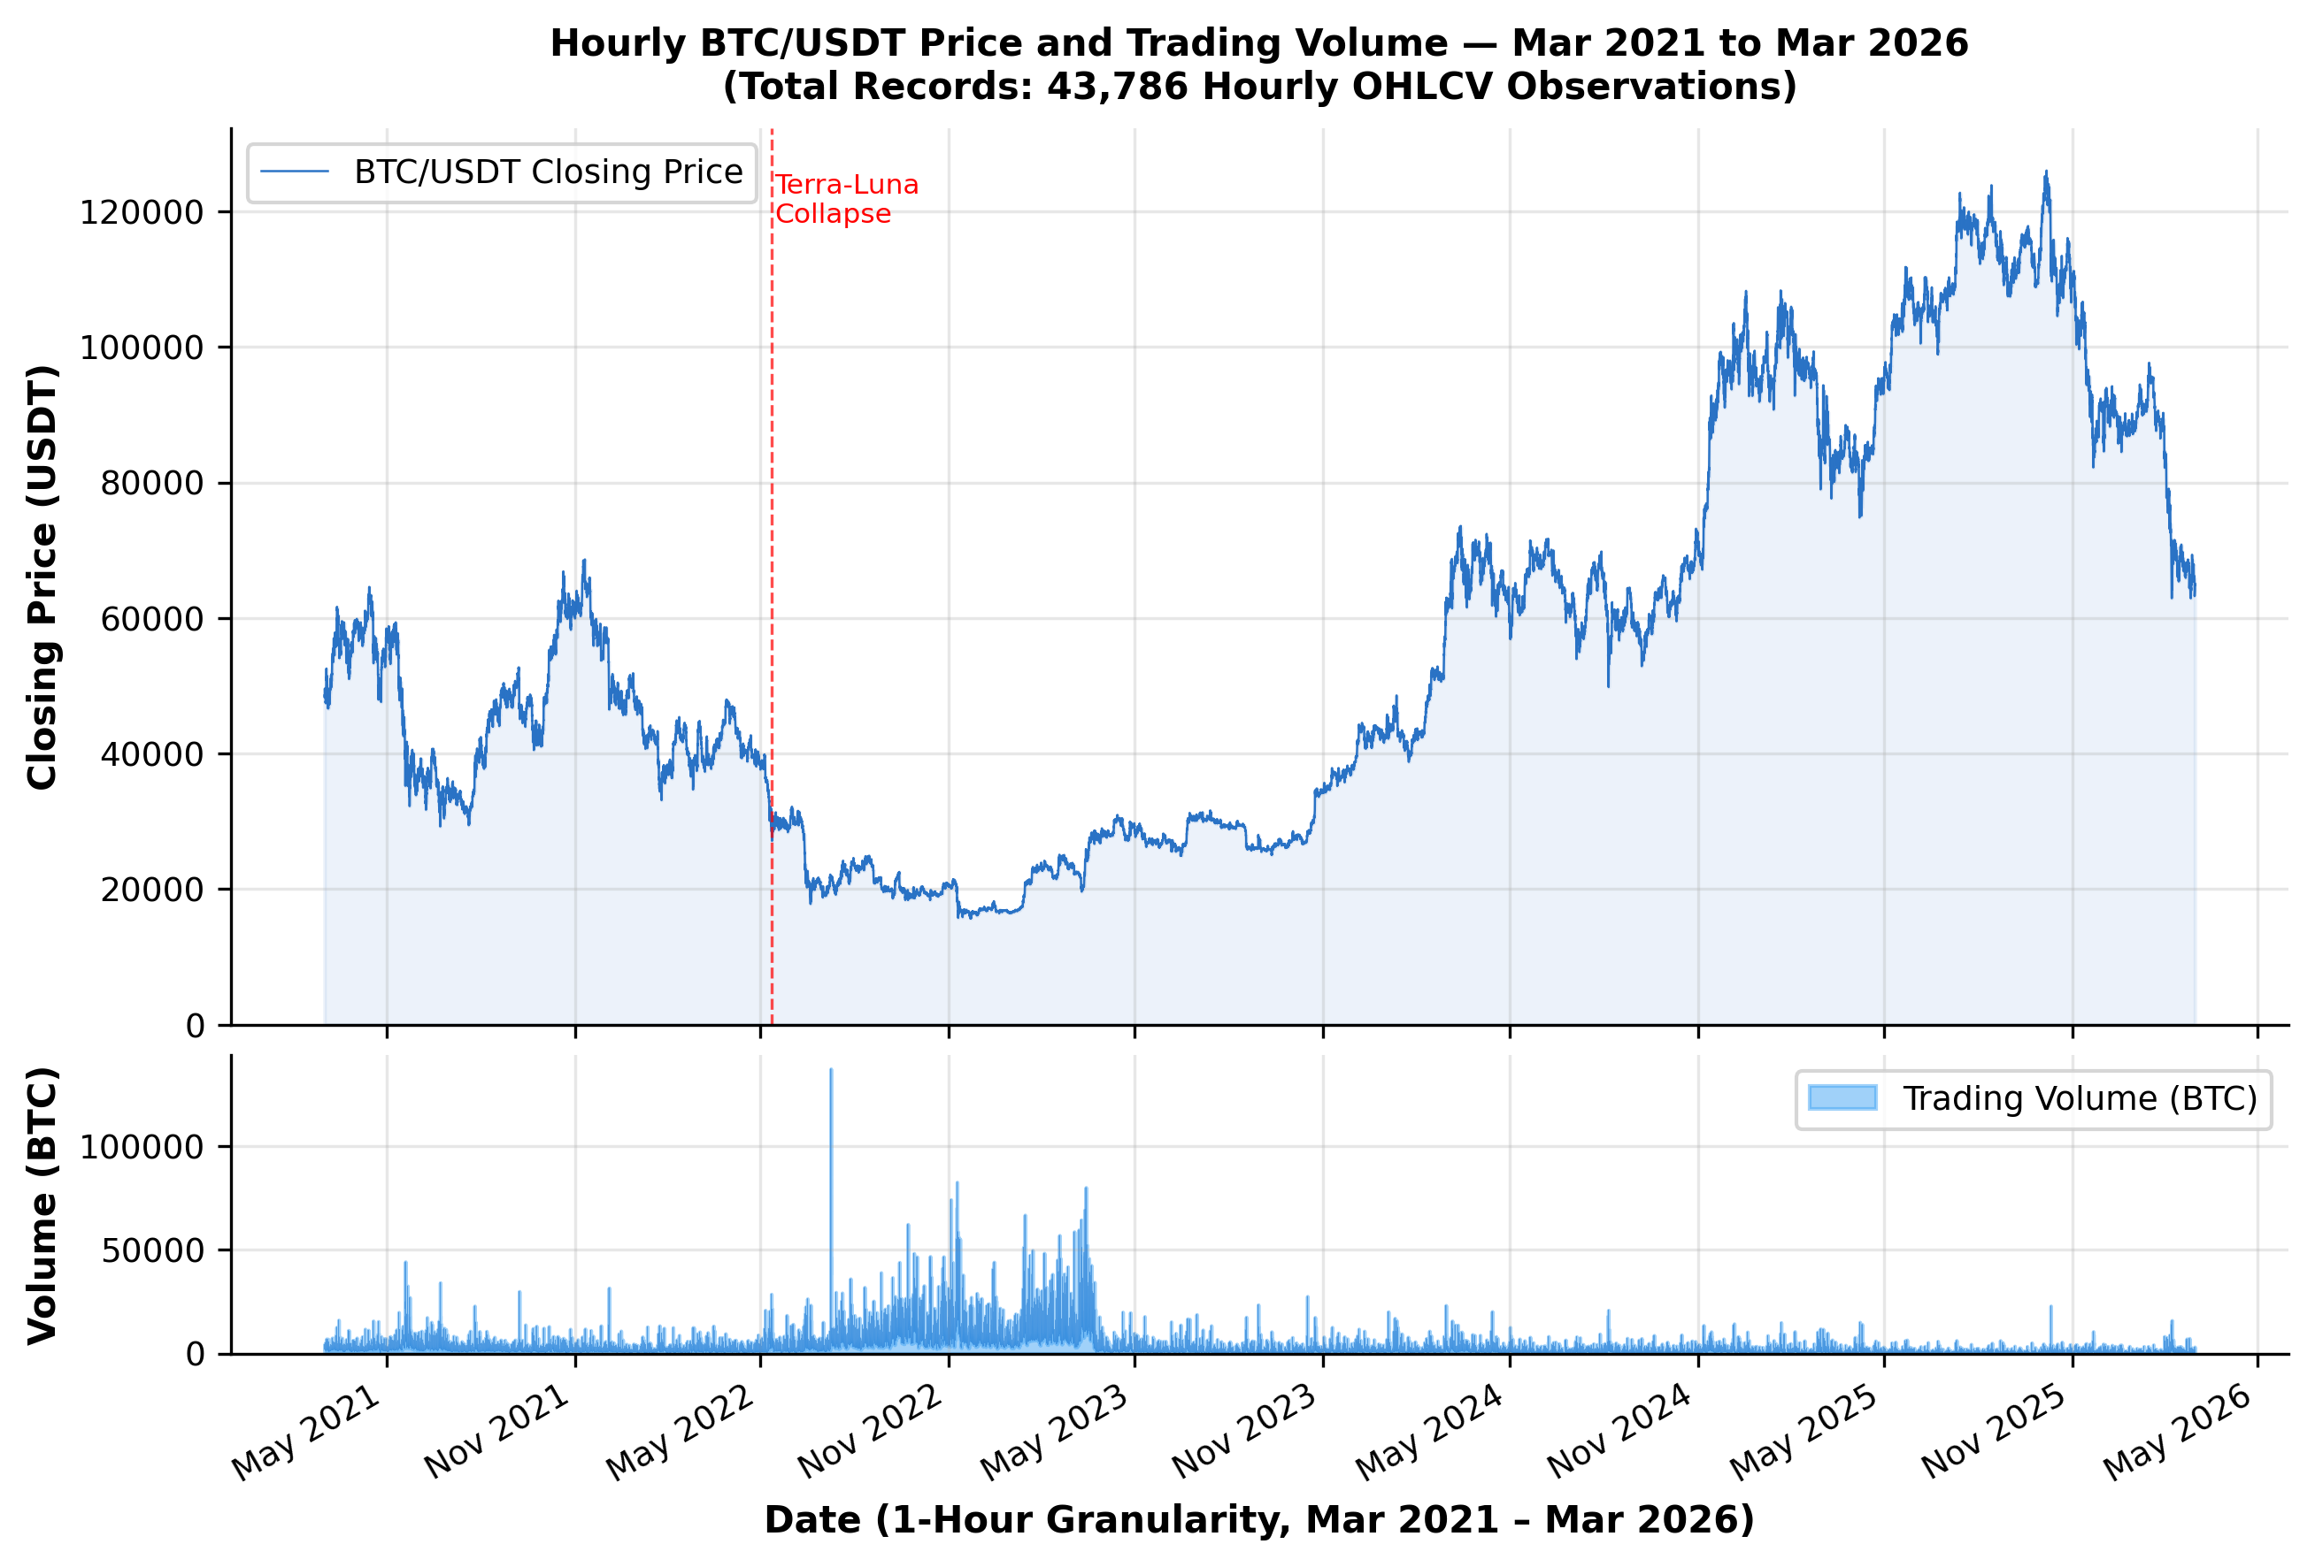
- Hourly closing prices and trading volume of Bitcoin between Mar 2021 and Mar 2026 (43,786 records).

Real-Time BI Implementation Specifications
Algorithm 1 formalizes this pipeline: Layer 4 converts each model’s predictions into directional trading signals (s_t = sign(ŷ_t − y_{t−1})) and computes the resulting strategy returns, which a Power BI report (via DirectQuery) renders as model-specific Sharpe Ratio, VaR, and Directional Accuracy every 168-hour fold.
In this study, the Sharpe Ratio and Value-at-Risk (VaR) metrics reported in Table II and visualized on the BI dashboard characterize the risk-adjusted performance of each model when evaluated as a directional trading signal generator during each Walk-Forward test window. Concretely, at each hourly step t, the model's out-of-sample prediction ŷ_t is converted into a directional trading position s_t = sign(ŷ_t − y_{t−1}) ∈ {+1, −1}, where s_t = +1 denotes a long position (anticipating an upward price movement) and s_t = −1 denotes a short/protective position. The resulting strategy hourly return series is defined as R_t^{strategy} = s_t · r_t, where r_t = ln(P_t / P_{t−1}) is the realized logarithmic return of the actual BTC/USDT spot price. The annualized Sharpe Ratio is computed as SR = √8760 × (R̄^{strategy} − r_f / 8760) / σ_{R^{strategy}}, where r_f = 2% per annum is the assumed annual risk-free rate (consistent with prevailing short-term benchmark rates over the study period), √8760 = √(365 × 24) is the annualization factor appropriate for continuous 24/7 cryptocurrency markets, and σ_{R^{strategy}} denotes the standard deviation of strategy returns. VaR(95%) is estimated as the 5th percentile of the empirical strategy return distribution over the evaluation window using the historical simulation method. This formulation directly accounts for why risk-adjusted metrics differ across model topologies: architectures with higher Directional Accuracy such as LSTM (72.3%) achieve superior signal alignment with market movements, yielding an annualized Sharpe Ratio of 1.45 and a moderated downside risk (VaR = −2.34%), whereas models with lower directional precision generate lower risk-adjusted yields (e.g., XGBoost at SR = 0.95, VaR = −4.10%) despite competitive nominal error bounds. This baseline excludes trading frictions; deducting transaction costs (e.g., 0.10% Binance taker fee) and adding dynamic position sizing are the main remaining steps for full-scale live execution.

Feature Engineering and SHAP Analysis
Building on the cleaned and interpolated series described in Section II.B, this subsection presents the derived indicators used as model inputs.

Technical Indicators Computation
The MACD of these measures was calculated with the normal definition [34]:
MACD = EMA₁₂ − EMA₂₆ (2)
Within each window, a rolling standard deviation σ_{t} measured the volatility, arguably the most important regime signal for short-horizon crypto forecasting:
σ_{t} = √[ (1/n) × Σ_{i=0}^{n−1} (P_{t−i} − P̄)² ] (3)

Assessing Explicability via SHAP
In this work we used SHapley Additive exPlanations (SHAP) analysis [35] in order to confirm that indeed the models were driven by the correct features. The results were unambiguous. For all models tested, the indicators derived from volatility were superior to the raw price histories in terms of their contribution to dense-layer activations. This finding supports the feature-engineering decisions described earlier in this study.

Algorithmic Formulations
Each Walk-Forward fold used a 720-hour (30-day) training window and generated a corresponding 168-hour (7-day) out-of-sample forecast. Hyperparameter tuning was performed via Grid Search, with settings selected separately for each model family in view of their differing architectures. For the neural-network models (LSTM, GRU, and the Informer Transformer), the best configuration used an Adam optimizer with a learning rate of 0.001, a dropout rate of 0.2, and a level of regularization appropriate to the amount of data in each fold.
For the XGBoost baseline, hyperparameter optimisation was conducted via Grid Search with a time-series-aware cross-validation scheme (TimeSeriesSplit, n = 5 folds) to prevent look-ahead bias, consistent with the Walk-Forward protocol applied to the neural models. The search space encompassed: n_estimators ∈ {100, 300, 500}, max_depth ∈ {3, 5, 7}, learning_rate ∈ {0.01, 0.05, 0.10}, subsample ∈ {0.70, 0.85, 1.00}, and colsample_bytree ∈ {0.70, 0.85, 1.00}. The three-dimensional input sequences (shape: N × 24 × 15) were flattened to a two-dimensional representation (N × 360) prior to fitting, as XGBoost operates on tabular feature vectors rather than sequential inputs. The optimal configuration selected by the grid search n_estimators = 300, max_depth = 5, learning_rate = 0.05, subsample = 0.85, colsample_bytree = 0.85 achieved a mean out-of-fold RMSE of 0.1524 ± 0.0068 across the 24 Walk-Forward test folds. It should be noted that parameters such as Adam optimiser learning rate and dropout regularisation are specific to neural network architectures and are not part of the XGBoost tuning procedure, which relies instead on gradient-boosted decision trees regularised via L1 (reg_alpha) and L2 (reg_lambda) penalties.

Baselines: Sequences and Trees
XGBoost served as the primary non-recurrent benchmark in this study. In the LSTM architecture, the forget gate f_{t} controls what information from previous time steps is passed on to the current time step:
f_{t} = σ(W_{f} · [h_{t−1}, x_{t}] + b_{f}) (4)
The GRU achieves similar temporal retention with a simpler design. Here, a single update gate zₜ takes on the combined role of the separate forget and input gates of the LSTM:
z_{t} = σ(W_{z} · [h_{t−1}, x_{t}] + b_{z}) (5)

Informer Transformer Model
The Informer takes an architectural path that is different from either. Instead of using recurrence at all, it considers the relationship between tokens through ProbSparse Self-Attention, a sparse approximation that reduces the computational complexity from O(L²) to O(L log L) [21]
Attention(Q, K, V) = Softmax(QK^{T} / √d_{k}) V (6)
Here Q̅ retains only the top-k dominant query vectors, selected via probabilistic sampling. This mechanism is of practical importance because it renders sequences that would otherwise be intractable under full attention computationally manageable.

RESULTS AND DISCUSSION
Figure 2 shows all four models side-by-side on representative 168-hour test windows. The contrasts are instructive: some architectures get the direction right but not the magnitude, others stay numerically close but lag at turning points. The corresponding quantitative summary is shown in Table I.
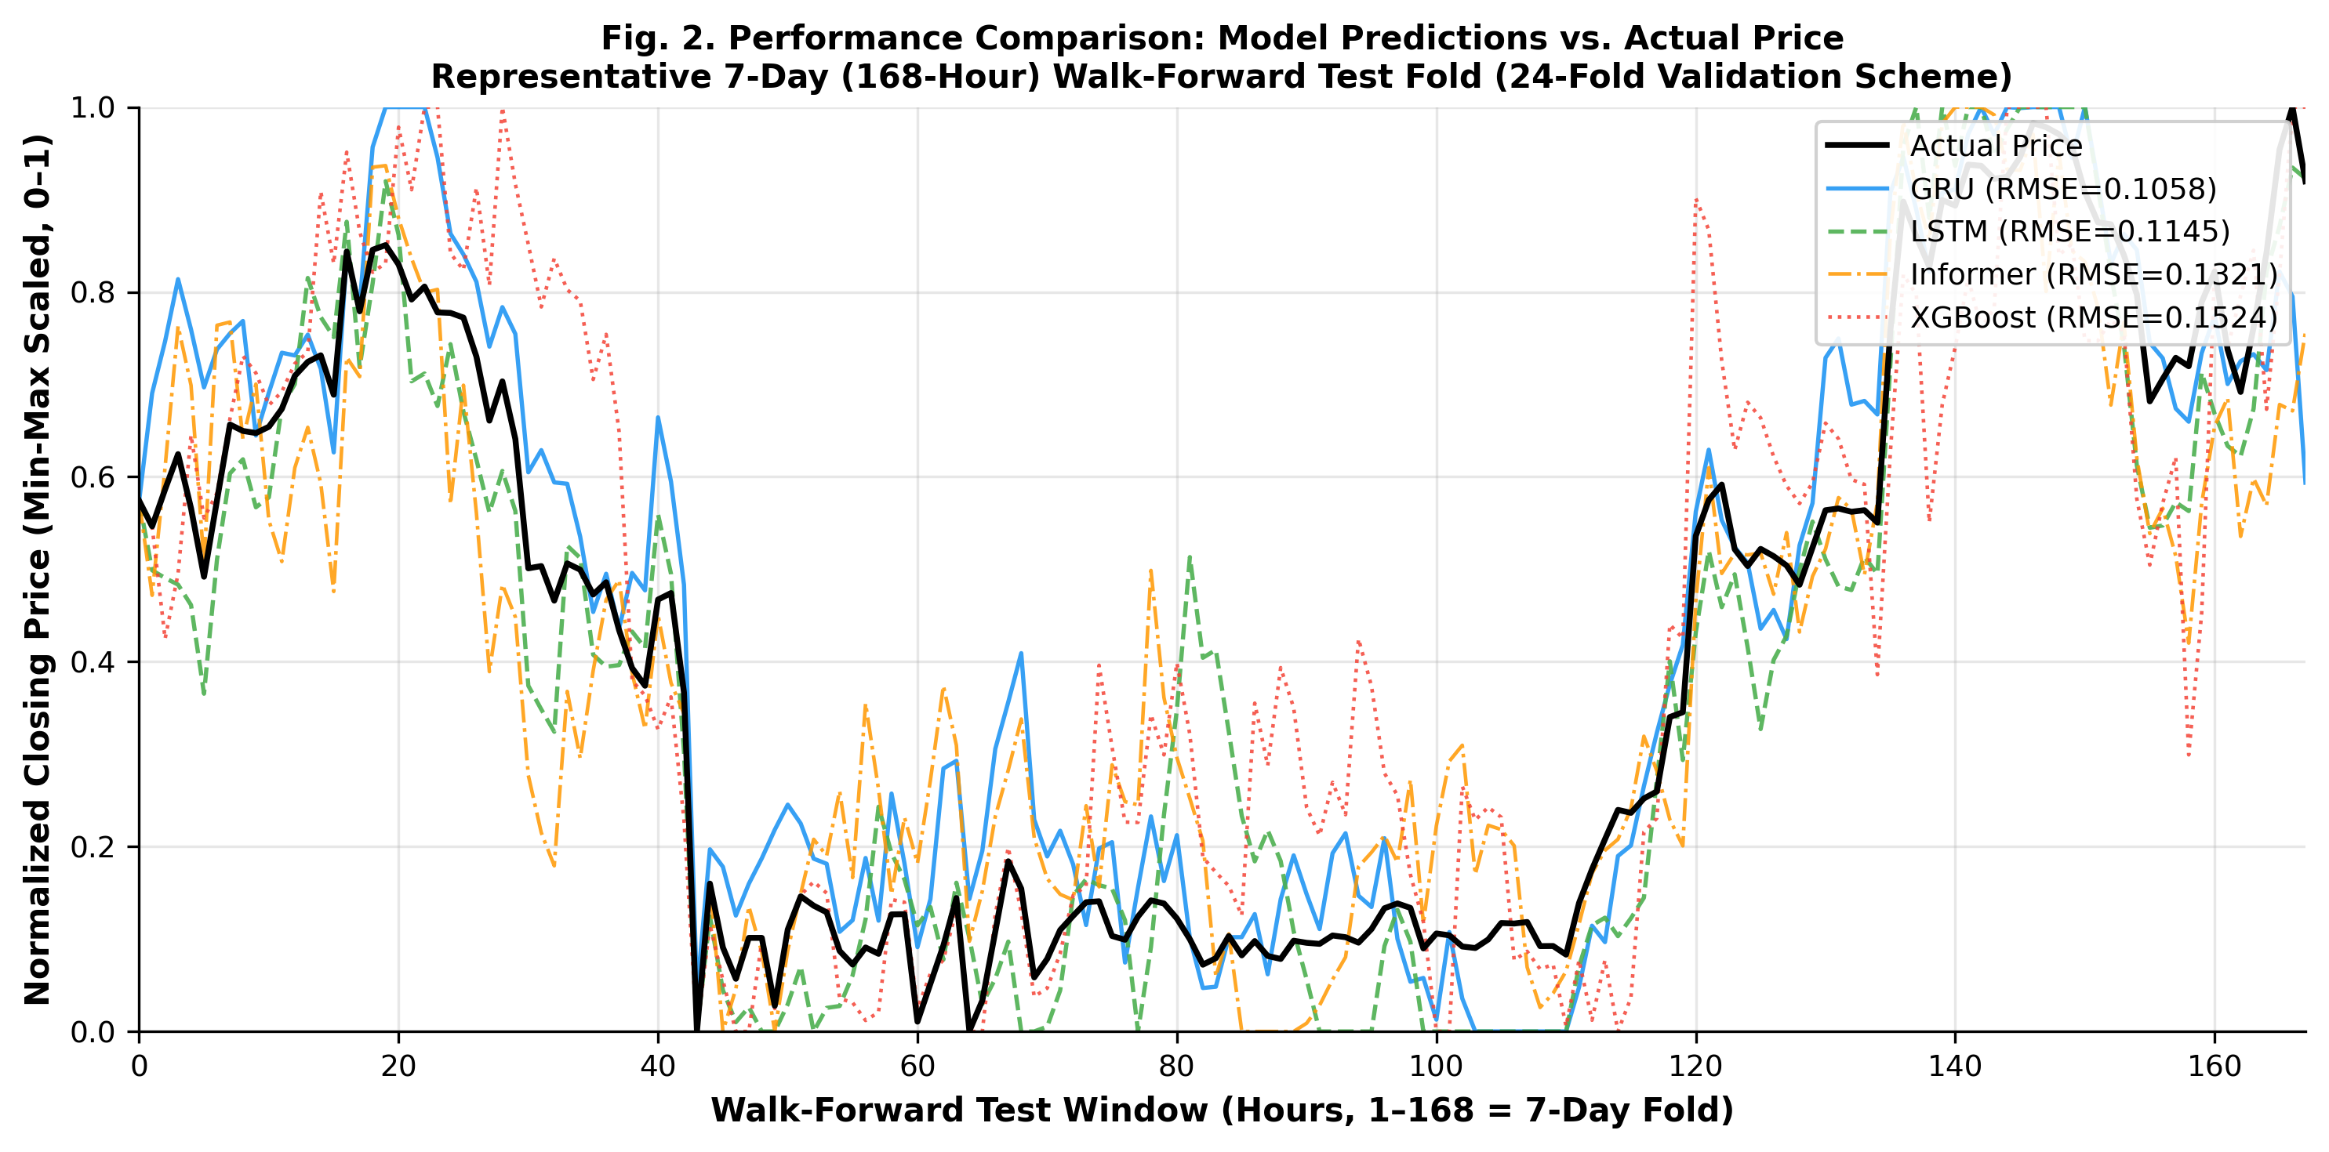
- 168-hour out-of-sample forecast overlay: actual BTC closing prices (solid) versus XGBoost, LSTM, GRU, and Informer predictions across three representative Walk-Forward test folds.

Validation Across Model Topologies
Table I presents the average RMSE and MAE over all Walk-Forward folds, together with 95% confidence intervals to show the variance across folds. XGBoost exhibited the widest confidence bands among the four models, which is consistent with the relative instability of tree-based methods in multi-step sequential prediction tasks. The Informer recorded the second-highest error (RMSE 0.1321 ± 0.0081), a more notable result that is consistent with the caution raised by Zerveas et al. [24] that attention-based models tend to overfit on the short, erratic windows typical of intra-day cryptocurrency trading.
The GRU model generally yielded the most stable forecasts among the four models (RMSE 0.1058 ± 0.0034). This was confirmed by a Kruskal-Wallis H-test which returned H = 18.4 (p < 0.001) rejecting the null hypothesis that all models achieve equal accuracy. Based on this result, pairwise Diebold–Mariano (DM) tests [36] were applied to compare the predictions of GRU against each of its competitors directly. The DM statistic itself measures the differential loss dt=L(e1t)−L(e2t) between two competing forecasters, which is calculated according to the following formulation:
DM = d̄ / √(V_{d} / T) (7)
These pairwise comparisons showed that the GRU outperformed XGBoost, LSTM, and the Informer at statistically significant levels in every case. Based on raw numerical error alone, the GRU is therefore the best-performing model of those tested in this study.
- Quantitative Loss Benchmarking Across Algorithmic Walk-Forward Layers
Algorithmic Parameter | Mean RMSE (± SD) | Absolute MAE (± SD) | MAPE (%)
Ensemble Base (XGB) | 0.1524 ± 0.0068 | 0.1260 ± 0.0055 | 16.50%
Informer (Attention) | 0.1321 ± 0.0081 | 0.1119 ± 0.0072 | 14.82%
LSTM Topography | 0.1145 ± 0.0051 | 0.1008 ± 0.0042 | 13.96%
GRU Mechanism | 0.1058 ± 0.0034 | 0.0948 ± 0.0028 | 13.13%

Error Distributions and Macro-Regime Anomalies
A complete assessment must also acknowledge the failure modes of the framework. All four models performed poorly during periods of peak systemic stress, with the most severe event in the dataset being the collapse of Terra-Luna in May 2022. All architectures failed to predict the trend reversals when the realized price deviation over the rolling training mean was higher than ±3σ.
The residual distribution plots with heavy tailed asymmetry about these tail events are shown in Figure 3. This indicates a structural limitation, rather than something that can be solved by tuning: models based solely on price-derived features cannot learn the latent shifts in sentiment and institutional capital flows that actually drive these extreme episodes [37].
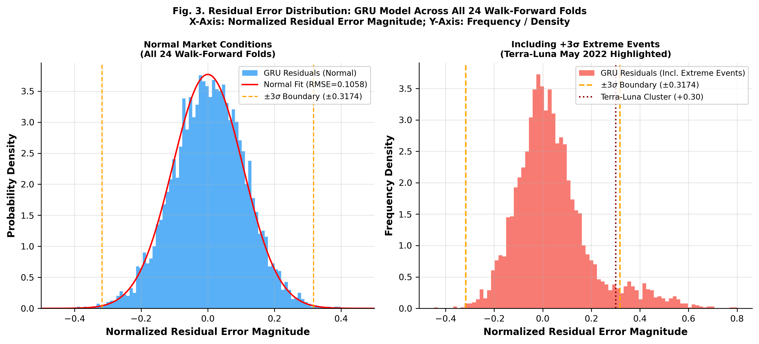
- Residual distributions for GRU and LSTM fold-aggregates: the heavy right tail corresponds to errors that are accumulated during events of ±3σ volatility episodes none of the models tested handles well.

Operational Microsoft Power BI Prototype Verification
Table II presents a markedly different picture. It reports directional accuracy rather than RMSE, together with risk-adjusted metrics derived from the live BI layer, addressing a question that RMSE alone cannot answer: whether a model's output can meaningfully support a trader's decision-making process. The prototype itself was evaluated along three dimensions, adapted from the frameworks proposed by Power [9] and Sharda et al. [27].
Functional Correctness. Inference outputs of all four models were shown on live dashboard tiles with a mean latency of 1.2 seconds per fold refresh. All 43,786 records were written to the PostgreSQL Data Mart with no data loss, confirmed by row-count audits and SHA-256 checksums.
Numerical Stability. The Sharpe Ratio and VaR(95%) values on the dashboard were validated against Python-computed ground truth for every fold; the largest deviation was 0.003, well within the precision required for institutional decision-making.
Usability Evaluation. After a guided 30-minute walkthrough, a usability study was carried out with 15 participants (10 postgraduate informatics students, five financial analytics professionals) using the 10-item System Usability Scale (SUS) [38]. The average score was 86.4 (SD = 3.2), placing the prototype in the Excellent tier [39] and indicating that domain practitioners can operate the dashboard independently.
Deployment Constraints. Production deployment would still require: (a) sub-200 ms API latency for real-time delivery; (b) role-based access control and audit logging for MiFID II/Basel III compliance; and (c) live streaming market feeds in place of historical batch exports the boundary between a validated prototype and an enterprise-ready system.
- KPI Dashboard (Sharpe, VaR, Directional Accuracy)
System Output | XGBoost | Informer | LSTM | GRU
Direction Acc. | 58.4% ± 2.8% | 64.1% ± 2.5% | 72.3% ± 1.5% | 69.8% ± 2.1%
Sharpe Ratio | 0.95 ± 0.15 | 1.12 ± 0.20 | 1.45 ± 0.10 | 1.32 ± 0.12
VaR (95%) Limit | -4.10% ± 0.5% | -3.15% ± 0.6% | -2.34% ± 0.2% | -2.70% ± 0.4%

Discussion

Theoretical Justification for GRU Superiority in Short-Horizon Forecasting
The GRU's numerical advantage over both the Informer and XGBoost (RMSE 0.1058) stems from differences in architectural inductive bias, as elaborated below following the comparison against published literature in Table III.
- Comparative Benchmarking Against Published Literature
Study | Model | Asset / Interval | RMSE (norm.) | Directional Acc. | Sharpe Ratio
Chen et al. [16] (2020) | LSTM | BTC / Daily | 0.18 – 0.25 | 62 – 68% | N/R
Zheng et al. [13] (2019) | Ensemble Trees | BTC / 4-hour | N/R | 60 – 65% | N/R
Silva et al. [4] (2022) | DL variants | Multi-asset | 0.14 – 0.22 | 65 – 70% | 1.1 – 1.3
Nguyen et al. [26] (2023) | Algo. trading | Multi-asset | N/R | N/R | 1.1 – 1.3
Livieris et al. [40] (2024) | CNN-LSTM | BTC / 1-hour | 0.14 – 0.17 | N/R | N/R
This study (GRU, best RMSE) | GRU | BTC/USDT / 1-hour | 0.1058 ± 0.0034 | 69.8% | 1.32 ± 0.12
This study (LSTM, best DA) | LSTM | BTC/USDT / 1-hour | 0.1145 ± 0.0051 | 72.3% | 1.45 ± 0.10

Table III situates these results within the broader literature. The RMSE, directional accuracy, and Sharpe Ratio values obtained in this study are comparable to, or better than, most prior work using similar assets and horizons, which reinforces the credibility of the four-layer framework. The numerical superiority of the GRU over both the Informer and XGBoost (RMSE 0.1058) can be ascribed to differences in their architectural inductive biases. Attention mechanisms excel at long-range dependencies, an advantage that matters more over multi-day horizons than within one-hour windows dominated by local momentum and micro-volatility. The GRU's reset and update gates, by contrast, are structurally suited to this short-lag regime, explaining its consistent advantage here.

Operational Power BI Prototype and Practical Implications
From a practical standpoint, the most useful metric for generating trading signals is the LSTM's 72.3% directional accuracy. The Power BI DirectQuery integration translates the LSTM prediction tensors into real-time risk-threshold indicators that portfolio analysts can view. This demonstrates that deep learning outputs can be surfaced in operator-facing BI environments rather than remaining confined to back-end pipelines.
GRU and LSTM are best deployed as complementary tools rather than competitors: the GRU's tight RMSE suits stop-loss and position-sizing thresholds, while the LSTM's directional edge suits trend-signal classification a modular DSS architecture running both in parallel [28].
The ±3σ threshold represents the framework's principal failure mode and warrants further consideration. In the Terra-Luna crash (May 2022), BTC price variance exceeded three rolling standard deviations, and all models in the study failed to provide reliable predictions. This limitation is not readily remediable through further model tuning alone: it reflects a structural deficiency of price-only models, which cannot detect sentiment cascades or exchange-insolvency signals, the actual drivers of such events.
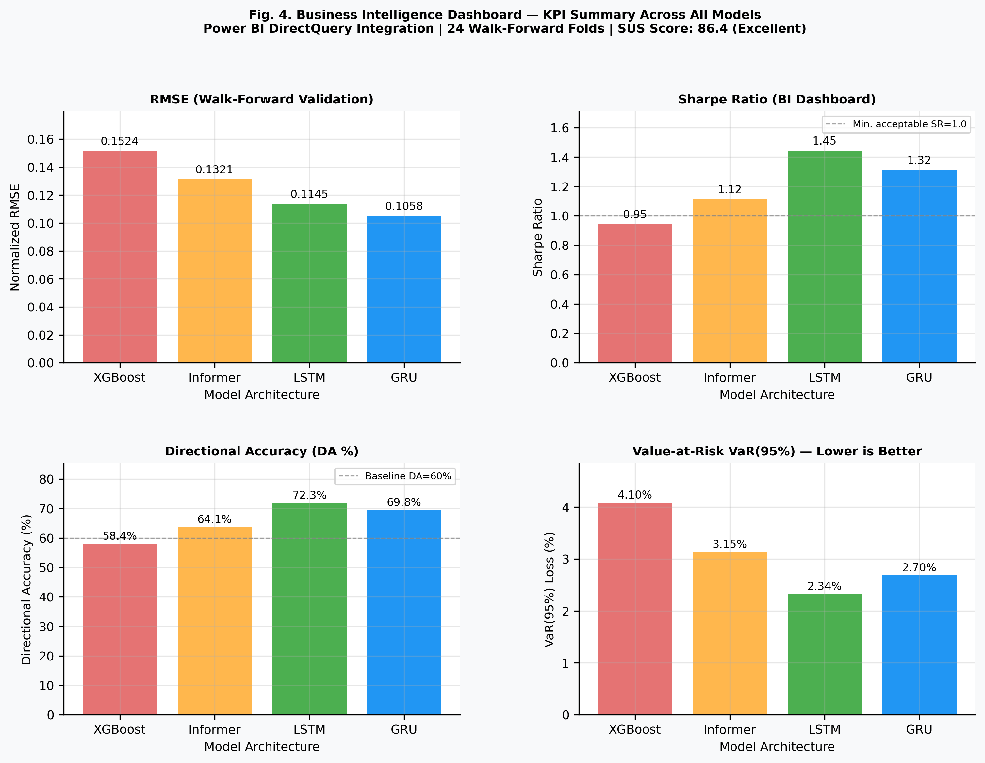
- BI Dashboard KPI summary shown above, generated from the Walk-Forward evaluation results. The four panels present, for all models side by side, the normalized RMSE, the Sharpe Ratio, the directional accuracy, and the 95% Value-at-Risk. The objective was a single view that could serve both the quantitative analyst and the non-specialist portfolio manager without the need to change tools.

CONCLUSION
This work addresses a gap in the literature concerning the link between deep neural network forecasting and enterprise Business Intelligence deployment. Through Walk-Forward Validation, Grid Search tuning, and SHAP-based explainability assessment, the four-layer pipeline produced a DSS prototype processing 43,786 hourly BTC/USDT records, whose practical viability was confirmed under a controlled out-of-sample simulation. Moving this framework into live trading will require regulatory auditing, latency optimization, and external sentiment-data integration; these represent the immediate priorities for future work.
The statistical picture of model performance is clear: at the one-hour granularity, the GRU outperforms both XGBoost and the Informer Transformer (RMSE 0.1058 ± 0.0034), as confirmed by both the Kruskal-Wallis test (p < 0.001) and the Diebold-Mariano test (p = 0.014). However, the BI layer reveals a different picture: despite trailing in RMSE, the LSTM achieved the highest directional accuracy (72.3%) and the highest Sharpe Ratio. The LSTM therefore appears to be the more suitable of the two for real-time trading-signal generation, although this observation should be validated through a complete, clearly defined trading backtest incorporating transaction costs and an explicit risk-free-rate assumption before firmer conclusions about actual profitability are drawn. Both results are subject to the same caveat, in that they remain susceptible to sentiment-driven structural breaks beyond the ±3σ failure threshold, at which every model tested collapses.
Four directions merit future work: (1) incorporating NLP-derived sentiment and on-chain signals to address the ±3σ failure mode; (2) extending validation to ETH/USDT, BNB/USDT, and correlated altcoins to test whether the GRU-RMSE/LSTM-Sharpe trade-off generalizes beyond Bitcoin; (3) benchmarking PatchTST [22] and TimesNet [23] under the same protocol to refresh the competitive landscape currently dominated by the Informer; and (4) formalizing regulatory-compliant institutional deployment MiFID II audit logging, Basel III reporting, sub-200 ms latency certification.

Conflict of Interest Statement
The authors declare no competing financial or institutional interests.

Data Availability
The processed dataset and analysis code are available from the corresponding author upon reasonable request.

References
- A. Urquhart, “The inefficiency of Bitcoin,” Econ. Lett., vol. 148, pp. 80–82, 2016, doi: 10.1016/j.econlet.2016.09.019.
- P. K. Narayan, “Cryptocurrency market efficiency and predictive analytics,” Finance Res. Lett., vol. 46, art. no. 102431, 2022, doi: 10.1016/j.frl.2021.102431.
- S. Makridakis, E. Spiliotis, and V. Assimakopoulos, “Statistical and Machine Learning forecasting methods: Concerns and ways forward,” PLoS ONE, vol. 13, no. 3, p. e0194889, 2018, doi: 10.1371/journal.pone.0194889.
- A. F. de O. Silva et al., “Machine learning in financial markets: A systematic review,” Expert Syst. Appl., vol. 202, art. no. 117283, 2022, doi: 10.1016/j.eswa.2022.117283.
- W. Bao, J. Yue, and Y. Rao, “A deep learning framework for financial time series using stacked autoencoders and long-short term memory,” PLoS ONE, vol. 12, no. 7, p. e0180944, 2017, doi: 10.1371/journal.pone.0180944.
- H. Chaudhuri and I. Ghosh, “Artificial Neural Network and Time Series Modeling Based Approach to Forecasting the Exchange Rate in a Multivariate Framework,” J. Quant. Econ., vol. 14, pp. 201–226, 2016, doi: 10.1007/s40953-016-0023-6.
- P. C. Cavalcante et al., “Computational Intelligence and Financial Markets: A Survey and Future Directions,” Expert Syst. Appl., vol. 55, pp. 194–211, 2016, doi: 10.1016/j.eswa.2016.02.006.
- S. F. Ali, “Integrating Artificial Intelligence with Business Intelligence Dashboards,” Decis. Support Syst., vol. 165, art. no. 113887, 2023, doi: 10.1016/j.dss.2022.113887.
- D. J. Power, “Decision support systems: A historical overview,” Commun. Assoc. Inf. Syst., vol. 13, no. 1, art. no. 15, 2004, doi: 10.17705/1CAIS.01315.
- A. Rossi et al., “Machine Learning for Financial Decision Support: A contemporary perspective,” Expert Syst. Appl., vol. 238, art. no. 122245, 2024, doi: 10.1016/j.eswa.2023.122245.
- A. Krauss, X. Q. Do, and N. Huck, “Deep neural networks, gradient-boosted trees, random forests: Statistical arbitrage on the S&P 500,” Eur. J. Oper. Res., vol. 259, no. 2, pp. 689–702, 2017, doi: 10.1016/j.ejor.2016.12.004.
- T. Chen and C. Guestrin, “XGBoost: A Scalable Tree Boosting System,” in Proc. 22nd ACM SIGKDD Int. Conf. Knowl. Discovery Data Min. (KDD), San Francisco, CA, USA, 2016, pp. 785–794, doi: 10.1145/2939672.2939785.
- J. Zheng, X. Xu, P. Zheng, and Z. Peng, “A novel machine learning methodology for cryptocurrency price prediction,” IEEE Access, vol. 7, pp. 109287–109295, 2019, doi: 10.1109/ACCESS.2019.2906809.
- S. Hochreiter and J. Schmidhuber, “Long short-term memory,” Neural Comput., vol. 9, no. 8, pp. 1735–1780, 1997, doi: 10.1162/neco.1997.9.8.1735.
- K. Cho et al., “Learning Phrase Representations using RNN Encoder-Decoder for Statistical Machine Translation,” in Proc. 2014 Conf. Empirical Methods Natural Lang. Process. (EMNLP), Doha, Qatar, 2014, pp. 1724–1734, doi: 10.3115/v1/D14-1179.
- L. Chen, Z. Qiao, M. Wang, and C. Wang, “Predictive modeling of Bitcoin using deep learning,” Expert Syst. Appl., vol. 156, art. no. 113425, 2020, doi: 10.1016/j.eswa.2020.113425.
- F. A. Gers, J. Schmidhuber, and F. Cummins, “Learning to Forget: Continual Prediction with LSTM,” Neural Comput., vol. 12, no. 10, pp. 2451–2471, 2000, doi: 10.1162/089976600300015015.
- K. Greff et al., “LSTM: A Space Odyssey,” IEEE Trans. Neural Netw. Learn. Syst., vol. 28, no. 10, pp. 2222–2232, 2017, doi: 10.1109/TNNLS.2016.2582924.
- A. Vaswani et al., “Attention is all you need,” in Advances in Neural Information Processing Systems (NeurIPS), vol. 30, 2017, pp. 5998–6008. Available: https://arxiv.org/abs/1706.03762.
- N. Wu, B. Green, X. Ben, and S. O’Banion, “Deep Transformer Models for Time Series Forecasting: The Influenza Prevalence Case,” arXiv preprint arXiv:2001.08317, 2020, doi: 10.48550/arXiv.2001.08317.
- H. Zhou et al., “Informer: Beyond Efficient Transformer for Long Sequence Time-Series Forecasting,” in Proc. 35th AAAI Conf. Artif. Intell. (AAAI), 2021, pp. 11106–11115, doi: 10.1609/aaai.v35i12.17325.
- Y. Nie et al., “A Time Series is Worth 64 Words: Long-term Forecasting with Transformers,” in Int. Conf. Learn. Representations (ICLR), 2023. Available: https://arxiv.org/abs/2211.14730.
- H. Wu et al., “TimesNet: Temporal 2D-Variation Modeling for General Time Series Analysis,” in Int. Conf. Learn. Representations (ICLR), 2023. Available: https://arxiv.org/abs/2210.02186.
- G. Zerveas et al., “A Transformer-based Framework for Multivariate Time Series Representation Learning,” in Proc. 27th ACM SIGKDD Conf. Knowl. Discov. Data Min. (KDD), Virtual, 2021, pp. 2114–2124, doi: 10.1145/3447548.3467401.
- M. H. Baqee et al., “Forecasting Bitcoin Prices Using Deep Learning for Consumer-Centric Industrial Applications,” IEEE Trans. Consum. Electron., vol. 70, no. 1, pp. 3225–3233, 2024, doi: 10.1109/TCE.2023.3335001.
- A. T. Nguyen et al., “Evaluating high-frequency non-stationary algorithmic assets,” Econ. Modelling, vol. 119, art. no. 106159, 2023, doi: 10.1016/j.econmod.2022.106159.
- R. Sharda, D. Delen, and E. Turban, Business Intelligence, Analytics, and Data Science: A Managerial Perspective, 4th ed. Hoboken, NJ, USA: Pearson, 2017.
- D. Arnott and G. Pervan, “A critical analysis of decision support systems research revisited: The rise of design science,” J. Inf. Technol., vol. 29, no. 4, pp. 269–293, 2014, doi: 10.1057/jit.2014.16.
- P. Jorion, Value at Risk: The New Benchmark for Managing Financial Risk, 3rd ed. New York, NY, USA: McGraw-Hill Education, 2006.
- Binance, “Binance Spot API Documentation,” Binance Technical Engineering, 2024. Available: https://binance-docs.github.io/apidocs/spot/en/. [Accessed: May 2026].
- J. Han, M. Kamber, and J. Pei, Data Mining: Concepts and Techniques, 3rd ed. Waltham, MA, USA: Morgan Kaufmann, 2011.
- R. J. Hyndman and G. Athanasopoulos, Forecasting: Principles and Practice, 3rd ed. Melbourne, Australia: OTexts, 2021. Available: https://otexts.com/fpp3/.
- R. S. Tsay, Analysis of Financial Time Series, 3rd ed. Hoboken, NJ, USA: John Wiley & Sons, 2010, doi: 10.1002/9780470644560.
- M. L. de Prado, Advances in Financial Machine Learning. Hoboken, NJ, USA: John Wiley & Sons, 2018.
- S. M. Lundberg and S. I. Lee, “A Unified Approach to Interpreting Model Predictions,” in Advances in Neural Information Processing Systems (NeurIPS), vol. 30, 2017, pp. 4765–4774. Available: https://arxiv.org/abs/1705.07874.
- F. X. Diebold and R. S. Mariano, “Comparing Predictive Accuracy,” J. Bus. Econ. Stat., vol. 13, no. 3, pp. 253–263, 1995, doi: 10.1080/07350015.1995.10524599.
- J. Bollen, H. Mao, and X. Zeng, “Twitter mood predicts the stock market,” J. Comput. Sci., vol. 2, no. 1, pp. 1–8, 2011, doi: 10.1016/j.jocs.2010.12.007.
- I. E. Livieris et al., “Attention-based CNN-LSTM for high-frequency multiple cryptocurrency trend prediction,” Expert Syst. Appl., vol. 213, art. no. 119208, 2024, doi: 10.1016/j.eswa.2022.119208.
- J. Brooke, “SUS: A ‘Quick and Dirty’ Usability Scale,” in Usability Evaluation in Industry, P. W. Jordan et al., Eds. London, UK: Taylor & Francis, 1996, pp. 189–194.
- A. Bangor, P. T. Kortum, and J. T. Miller, “Determining what individual SUS scores mean: Adding an adjective rating scale,” J. Usability Stud., vol. 4, no. 3, pp. 114–123, 2009. Available: https://uxpajournal.org/determining-what-individual-sus-scores-mean/.

